**C:\Documents and Settings\dogrady-cunniff\Local Settings\Temporary Internet Files\Content.IE5\2HSMJBNZ\MC900391164[1].wmfTaking apart a flashlight**

Take apart a flashlight, draw ALL of the separate components below and label them

1. There are usually no wires in the flashlight. Why not?
2. Put the flashlight back together. Does it matter which way you put the battery into the case?
3. How does the circuit work? Describe what is happening in complete sentences.

**C:\Documents and Settings\dogrady-cunniff\Local Settings\Temporary Internet Files\Content.IE5\2HSMJBNZ\MC900391164[1].wmfTaking apart a flashlight**

Take apart a flashlight, draw ALL of the separate components below and label them

1. There are usually no wires in the flashlight. Why not?
2. Put the flashlight back together. Does it matter which way you put the battery into the case?
3. How does the circuit work? Describe what is happening in complete sentences.

Name: ____________________________

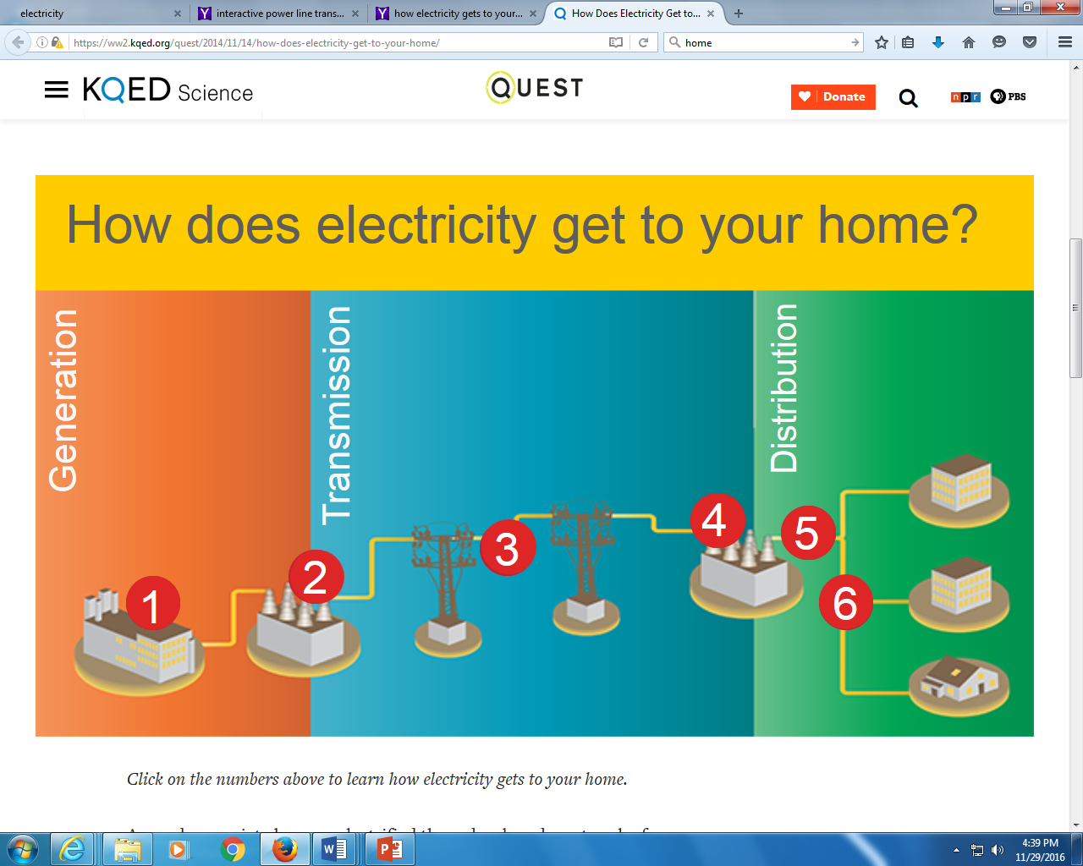

<https://ww2.kqed.org/quest/2014/11/14/how-does-electricity-get-to-your-home/>

1. __________________________________________________________
2. __________________________________________________________
3. __________________________________________________________
4. ___________________________________________________________
5. ___________________________________________________________
6. ___________________________________________________________

Name: ____________________________



<https://ww2.kqed.org/quest/2014/11/14/how-does-electricity-get-to-your-home/>

1. __________________________________________________________
2. __________________________________________________________
3. __________________________________________________________
4. ___________________________________________________________
5. ___________________________________________________________
6. ___________________________________________________________